Activity
Question:
A university wants to analyze the career pathways of students after graduation. The available dataset records the flow of students from their academic departments to specializations and finally to their career outcomes.
The dataset contains the following hierarchy:
- Departments: Computer Science, Information Technology, Electronics, Mechanical, Civil
- Specializations: AI & ML, Data Science, Cyber Security, Embedded Systems, Manufacturing, Construction
- Career Outcomes: Software Engineer, Data Analyst, Research, Higher Studies
The relationships between these categories are stored as source node, target node, and flow value, where the flow value represents the number of students moving from one stage to the next.
Using R and the networkD3 package, answer the following:
- Create a Sankey Plot representing the complete flow of students from departments to specializations and career outcomes.
- Configure the diagram with:
  - Node width = 35
  - Font size = 14
  - Career outcomes displayed on the right side of the diagram.
- Interpret the visualization and identify:
  - The specialization receiving the highest number of students.
  - The career outcome with the largest overall inflow.
  - Which department contributes the most students to Software Engineer positions.
- Explain why a Sankey diagram is more appropriate than a bar chart or pie chart for visualizing this dataset.
- Suggest two improvements that would make the visualization more informative for university administrators.
Expected Output:
A Sankey diagram showing the flow of students from Departments → Specializations → Career Outcomes, along with a brief interpretation of the major pathways and student distribution.
Database:
ID | Node
0 | Computer Science
1 | Information Technology
2 | Electronics
3 | Mechanical
4 | Civil
5 | AI & ML
6 | Data Science
7 | Cyber Security
8 | Embedded Systems
9 | Manufacturing
10 | Construction
11 | Software Engineer
12 | Data Analyst
13 | Research
14 | Higher Studies
Link table:
Source | Target | Value
0 | 5 | 80
0 | 6 | 70
0 | 7 | 50
1 | 6 | 60
1 | 7 | 50
2 | 8 | 90
3 | 9 | 100
4 | 10 | 80
5 | 11 | 50
5 | 13 | 30
6 | 11 | 40
6 | 12 | 60
6 | 14 | 30
7 | 11 | 35
7 | 13 | 25
8 | 13 | 40
8 | 14 | 50
9 | 11 | 70
10 | 11 | 50
10 | 14 | 30

Aim:
To create a Sankey Diagram in R using the networkD3 package to visualize the flow of students from Departments → Specializations → Career Outcomes, and identify the major career pathways.

Algorithm:
- Load the networkD3 library.
- Create a nodes data frame containing all departments, specializations, and career outcomes.
- Create a links data frame with source, target, and flow values.
- Use the sankeyNetwork() function to generate the Sankey diagram.
- Set:
  - nodeWidth = 35
  - fontSize = 14
  - sinksRight = TRUE (career outcomes displayed on the right).
- Analyze the thickness of links to identify the major pathways.
Program:
# Install package (Run once)
install.packages("networkD3")
# Load library
library(networkD3)
# Create Nodes
nodes <- data.frame(
name = c(
"Computer Science",
"Information Technology",
"Electronics",
"Mechanical",
"Civil",
"AI & ML",
"Data Science",
"Cyber Security",
"Embedded Systems",
"Manufacturing",
"Construction",
"Software Engineer",
"Data Analyst",
"Research",
"Higher Studies"
)
)
# Create Links
links <- data.frame(
source = c(0,0,0,1,1,2,3,4,5,5,6,6,6,7,7,8,8,9,10,10),
target = c(5,6,7,6,7,8,9,10,11,13,11,12,14,11,13,13,14,11,11,14),
value = c(80,70,50,60,50,90,100,80,50,30,40,60,30,35,25,40,50,70,50,30)
)
# Create Sankey Diagram
sankeyNetwork(
Links = links,
Nodes = nodes,
Source = "source",
Target = "target",
Value = "value",
NodeID = "name",
fontSize = 14,
nodeWidth = 35,
sinksRight = TRUE
)

Interpretation:

1. Specialization receiving the highest number of students
Total inflow:
  - AI & ML = 80
  - Data Science = 130 (70 + 60)
  - Cyber Security = 100 (50 + 50)
  - Embedded Systems = 90
  - Manufacturing = 100
  - Construction = 80
Answer: Data Science (130 students) receives the highest number of students.

2. Career outcome with the largest overall inflow
Total inflow:
- Software Engineer = 50 + 40 + 35 + 70 + 50 = 245
- Data Analyst = 60
- Research = 30 + 25 + 40 = 95
- Higher Studies = 30 + 50 + 30 = 110
Answer: Software Engineer (245 students) has the largest overall inflow.

3. Department contributing the most students to Software Engineer positions
Software Engineer receives students from:
- AI & ML ← Computer Science = 50
- Data Science ← Computer Science = 40
- Cyber Security ← Computer Science = 35
- Manufacturing ← Mechanical = 70
- Construction ← Civil = 50
Department-wise contribution:
- Computer Science = 125
- Mechanical = 70
- Civil = 50
- Information Technology = 40 + 35 = 75
- Electronics = 0
Answer: Computer Science (125 students) contributes the highest number of students to Software Engineer careers.

Why Sankey Diagram is Better?
A Sankey Diagram is more suitable than a bar chart or pie chart because:
- It clearly shows the flow of students between multiple stages.
- The width of each link represents the number of students.
- It visualizes relationships among departments, specializations, and career outcomes simultaneously.
- Bar and pie charts can compare totals but cannot effectively display transitions between categories.
Output:
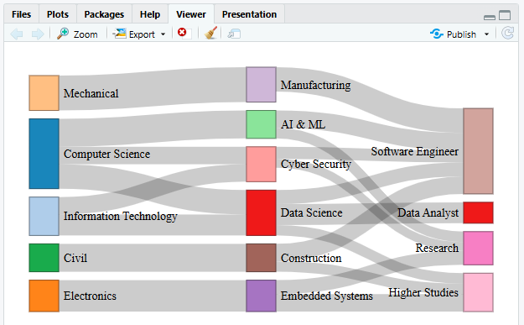

Result:
A Sankey Diagram is successfully created showing the flow of students from Departments → Specializations → Career Outcomes. The visualization indicates that:
- Data Science receives the highest number of students (130).
- Software Engineer is the most common career outcome (245 students).
- Computer Science contributes the largest number of students to Software Engineer positions (125 students).
The Sankey diagram effectively highlights the major student pathways and provides a clear overview of career distribution after graduation.

